**VISHWESHWARAYA TECHNOLOGICAL UNIVERSITY**

## Jnana Sangama, Belgaum - 590018



Department of Information Science and Engineering

A MINI PROJECT REPORT ON

“Workout Management System”

**Submitted by:**

## H. M. SHARANYA (1CR18IS056)

## SOORAJ M. SINGH (1CR18IS151)

Under the guidance of

**Dr. Sudhakar K N Assoc. Professor, Dept, ISE**

Department of Information Science and Engineering



CMR INSTITUTE OF TECHNOLOGY

**#132, AECS layout, IT park road, Kundalahalli, Bangalore-560 037**

# CMR INSTITUTE OF TECHNOLOGY

**BANGLORE - 37**



DEPARTMENT OF INFORMATION SCIENCE AND ENGINEERING 2020-21

# CERTIFICATE

This is to certify that the mini project entitled “**WORKOUT MANAGEMENT SYSTEM**” is a bonafide work carried out by **H. M. SHARANYA** (1CR18IS056) and **SOORAJ M. SINGH** (1CR18IS151) bonafide students of CMR INSTITUTE OF TECHNOLOGY in partial fulfillment for the mini project in Mobile Application Development Laboratory, 6th semester, Information Science & Engineering, Bengaluru during the year 2020-21. It is certified that all the corrections/suggestions indicated for internal assessment have been incorporated in the Report. The Mini Project Report has been approved as it satisfies the academic requirements in respect of Project work prescribed for the said degree.

Mrs. Akhilaa Dr. Farida Begam

Assistant Professor Head of Department

Dept of ISE Dept of ISE

CMRIT CMRIT

**External Viva**

Name of Examiner Signature with date

# Table of Contents

**Title Page No.**

Acknowledgement i

Abstract ii

Chapter 1 Introduction 1

* 1. Brief Introduction 1
     1. Android 1
     2. Android Architecture 1
     3. Android Studio 2
  2. Problem Statement 2
  3. Objectives 2
  4. Methodology 3

Problem Statement 3

Chapter 2

Literature Review 4

Chapter 3

Time Schedule 5

Chapter 4

Front-end Design 6

Chapter 5

Business Logic 7

Chapter 6

Testing 20

Chapter 7

Conclusion & Future Enhancements 21

References 22

# ACKNOWLEDGEMENT

### The satisfaction and euphoria that accompany a successful completion of any task would be incomplete without the mention of people who made it possible, success is the epitome of hard work and perseverance, but steadfast of all is encouraging guidance.

It is with gratitude I acknowledge all those whose guidance and encouragement served as beacon of light and crowned our effort with success.

I take this opportunity to thank our institution CMRIT for having given us an opportunity to carry out this project.

I would like to thank **Dr. Sanjay Jain**, Principal, CMRIT, for providing us all the Facilities to work on this project. I am indebted to him for being our pillar of strength and Inspiration.

I would also like to thank **Dr. Farida Begam,** Professor and HOD, Department of Information Science and Engineering, CMRIT, Bangalore who shared his opinions and experiences through which I received the required information crucial for the project.

I am grateful to **Dr. Sudhakar K N**, Assoc. Professor, Department of Information Science and Engineering, CMRIT, for his valuable suggestions and support, which has Sustained me throughout the course of the project.

I would also like to thank all the faculty members who have always been very cooperative and generous. Conclusively, I also thank all the non-teaching staff and all others who have done immense help directly or indirectly during my project.

**H. M. SHARANYA (1CR18IS056)**

**SOORAJ M. SINGH (1CR18IS151)**

# ABSTRACT

Due to the coronavirus outbreak gyms can no longer function at full capacity and hence occasionally people are required to either not go to the gym at all or divide their weekly workouts into home workouts and workouts at the gym.

Fit Check is an Android project. It helps the user to perform the gym session that workout at home with ease with instruction from a trainer. To assist the user set of tasks as part of the workout routine assigned by trainer for each day of the week. To run the project you will need Android Studio. So before you run the project make sure that you have Android Studio on your computer.

Trainer will be able to set the routine for each day and monitor whether user has completed the day’s workout and hence allow him to plan future workouts for progression of user’s fitness. The project is simple to understand. Moreover, the project is made in Java, the programming language for the Android Studio.

# INTRODUCTION

#### Introduction

As the smart phones and the Android system started getting popular, operations like listening to music, watching videos, tweeting, etc can be moved from the computer to a phone now. The applications on the market today are mostly commercial applications, and contain a large number of built-in advertising. If the user prefers to remove the built-in advertising, a certain price must be paid to reach that and this is not convenient. Meanwhile, because of the unfair competition of IT, many applications built illegal program to steal user information and cause some damage to user’s personal privacy. Sometimes, users will pay more attention to the user experience of software. Therefore, the development of the application can not only be limited to the function, more attention should be paid to the user's experience. After studying some previous Android applications and access to large amounts of materials, we utilize the Java language, the Eclipse platform, Android ADT and the Android SDK to develop these three mobile applications. These systems have a nice interface and smooth operation. These Apps won’t steal any personal information, but can exclude useless information and bring a wonderful user experience.

#### Android

Android is a mobile operating system (OS) currently developed by Google, based on the Linux kernel and designed primarily for touchscreen mobile devices such as smartphones and tablets. Android's user interface is mainly based on direct manipulation, using touch gestures that loosely correspond to real-world actions, such as swiping, tapping and pinching, to manipulate on-screen objects, along with a virtual keyboard for text input. In addition to touchscreen devices, Google has further developed Android TV for televisions, Android Auto for cars, and Android Wear for wrist watches, each with a specialized user interface. Variants of Android are also used on notebooks, game consoles, digital cameras, and other electronics. Initially developed by Android, Inc., which Google bought in 2005, Android was unveiled in 2007, along with the founding of the Open Handset Alliance – a consortium of hardware, software, and telecommunication companies devoted to advancing open standards for mobile devices.

#### Android Architecture

We studied the Android system architecture. Android system is a Linux-based system, Use of the software stack architecture design patterns. The Android architecture consists of four layers: Linux kernel, Libraries and Android runtime, Application framework and Applications. Each layer of the lower encapsulation, while providing call interface to the upper.

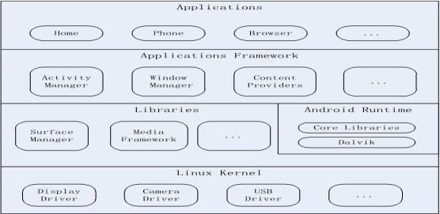

#### Android Studio

Android Studio is an integrated development environment (IDE) for developing for the Android platform. It was announced on May 16, 2013 at the Google I/O conference. Android Studio is freely available under the Apache License 2.0. Android Studio was in early access preview stage starting from version 0.1 in May 2013, then entered beta stage starting from version 0.8 which was released in June 2014. The first stable build was released in December 2014, starting from version 1.0. Based on JetBrains' IntelliJ IDEA software, Android Studio is designed specifically for Android development. It is available for download on Windows, Mac OS X and Linux, and replaced Eclipse Android Development Tools (ADT) as Google's primary IDE for native Android application development.

#### Problem Statement:

#### To write a program that can help track and maintain accountability of workouts at home and gyms.

#### Trainers must assign members with workout tasks for each day of the week and members must mark the workouts on completion of the routine.

#### Objective

There are 5 objectives in this project:

1. To setup Android software development kit.
2. To write a program that can help track and maintain accountability of workouts at home and gyms.
3. Crash handling and debugging.
4. Generate APK.
5. Upload application on Google Playstore.

#### Methodology

This project is made by using Android studio, Virtual emulator and Photoshop. The programming languages used for building the application are Java, XML and C++. User interface is handled using XML codes. Backend programming is handled mainly through set of java codes. Native libraries are accessed through set of predefined C++ codes.

# LITERATURE REVIEW

**Paper 1**: Research on development of android applications. This article gives a detailed introduction of android application framework and the working principal of android applications.

**Paper 2:** A model driven approach for android applications development This paper proposes a MDE approach for android applications development, which addresses how to model specific aspects of android applications, as intent and a data/service request, using standard UML notations. Moreover, it supports static and behavioral code generation from UML class and sequence diagrams, according to the rules imposed by the android platform. To demonstrate our approach, a case study was conducted, in which an android application was modeled in UML and code was generated from it. To generate code, the extension of GenCode was used. However, the actual version of GenCode tool that supports the proposed approach, only made an automatic transformation from UML class and sequence diagrams to the target android Java code, without consider any optimization in the generated code. As future work, we plan to extend this tool in order to consider the good practices for android development and thus generating efficient code.

# TIME SCHEDULE

Team Members

The team members working for the preparation of this project are:

H. M. Sharanya (1CR18IS056)

Sooraj M. Singh (1CR18IS151)

Time Chart

|  |  |  |  |  |  |  |  |
| --- | --- | --- | --- | --- | --- | --- | --- |
| Sl.  No. | Week | Week 1 | Week 2 | Week 3 | Week 4 | Week 5 | Week 6 |
| Strategies |
| 1) | Problem Identification |  |  |  |  |  |  |
| 2) | Research and analysis |  |  |  |  |  |  |
| 3) | Design |  |  |  |  |  |  |
| 4) | Coding |  |  |  |  |  |  |
| 5) | Implementation & testing |  |  |  |  |  |  |
| 6) | Project finalization |  |  |  |  |  |  |
| 7) | Documentation |  |  |  |  |  |  |

# FRONT-END DESIGN

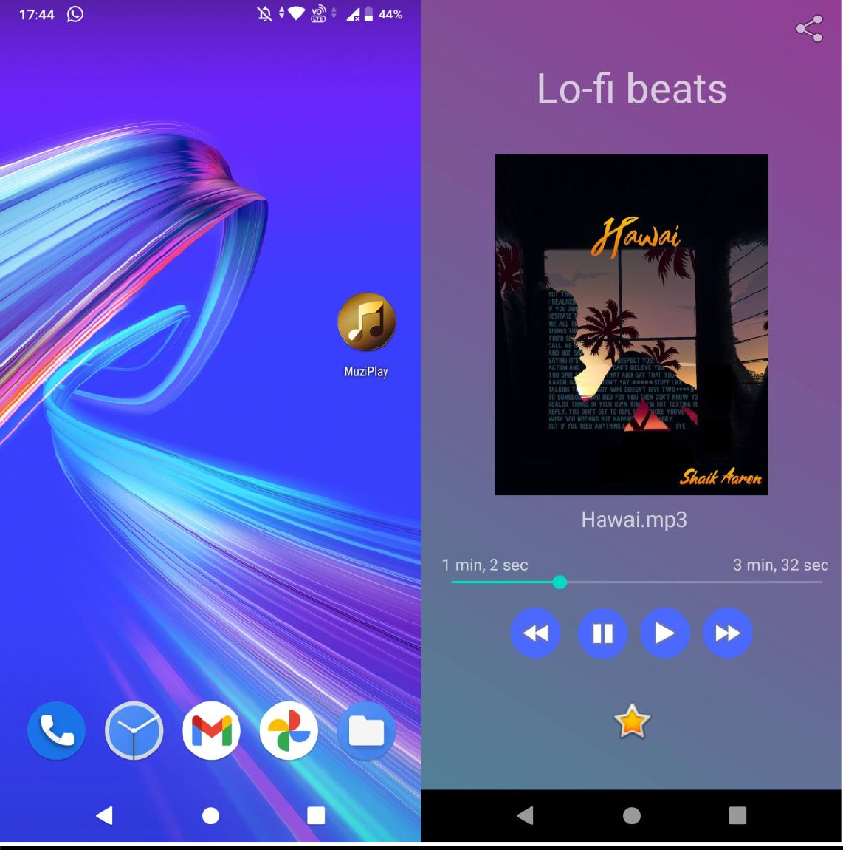

# BUSINESS LOGIC

#### mainActivity.java File

package com.example.muziplay; import android.app.Activity; import android.content.Intent; import android.media.MediaPlayer; import android.os.Bundle;

import android.os.Handler; import android.view.View; import android.view.Window;

import android.view.WindowManager; import android.widget.ImageButton; import android.widget.ImageView; import android.widget.SeekBar; import android.widget.TextView; import android.widget.Toast;

import java.util.concurrent.TimeUnit;

public class MainActivity extends Activity { private ImageButton b1,b2,b3,b4,bt; private ImageView iv;

private MediaPlayer mediaPlayer;

private double startTime = 0; private double finalTime = 0;

private final Handler myHandler = new Handler();; private int forwardTime = 5000;

private int backwardTime = 5000; private SeekBar seekbar;

private TextView tx1,tx2,tx3;

public static int oneTimeOnly = 0; @Override

protected void onCreate(Bundle savedInstanceState) { super.onCreate(savedInstanceState); requestWindowFeature(Window.FEATURE_NO_TITLE);

this.getWindow().setFlags(WindowManager.LayoutParams.FLAG_FULLSCREEN,Window Manager.LayoutParams.FLAG_FULLSCREEN);

setContentView(R.layout.activity_main);

AndroidLikeButton androidLikeButton = findViewById(R.id.Like); androidLikeButton.setCurrentlyLiked(false);

androidLikeButton.setOnLikeEventListener(new AndroidLikeButton.OnLikeEventListener() {

@Override

public void onLikeClicked(AndroidLikeButton androidLikeButton) { Toast.makeText(getApplicationContext(), "Liked

Song",Toast.LENGTH_SHORT).show();

}

@Override

public void onUnlikeClicked(AndroidLikeButton androidLikeButton) { Toast.makeText(getApplicationContext(), "Disliked

Song",Toast.LENGTH_SHORT).show();

}

});

b1 = (ImageButton) findViewById(R.id.button); b2 = (ImageButton) findViewById(R.id.button2); b3 = (ImageButton)findViewById(R.id.button3); b4 = (ImageButton)findViewById(R.id.button4); iv = (ImageView)findViewById(R.id.imageView);

bt = (ImageButton) findViewById(R.id.share); tx1 = (TextView)findViewById(R.id.textView2); tx2 = (TextView)findViewById(R.id.textView3); tx3 = (TextView)findViewById(R.id.textView4); tx3.setText("Hawai.mp3");

mediaPlayer = MediaPlayer.create(this, R.raw.hawai); seekbar = (SeekBar)findViewById(R.id.seekBar); seekbar.setClickable(false);

b2.setEnabled(false);

b3.setOnClickListener(new View.OnClickListener() { @Override

public void onClick(View v) {

Toast.makeText(getApplicationContext(), "Playing song",Toast.LENGTH_SHORT).show();

mediaPlayer.start();

finalTime = mediaPlayer.getDuration(); startTime = mediaPlayer.getCurrentPosition();

if (oneTimeOnly == 0) { seekbar.setMax((int) finalTime); oneTimeOnly = 1;

}

tx2.setText(String.format("%d min, %d sec", TimeUnit.MILLISECONDS.toMinutes((long) finalTime), TimeUnit.MILLISECONDS.toSeconds((long) finalTime) -

TimeUnit.MINUTES.toSeconds(TimeUnit.MILLISECONDS.toMinutes((long)

finalTime)))

);

tx1.setText(String.format("%d min, %d sec", TimeUnit.MILLISECONDS.toMinutes((long) startTime), TimeUnit.MILLISECONDS.toSeconds((long) startTime) -

TimeUnit.MINUTES.toSeconds(TimeUnit.MILLISECONDS.toMinutes((long)

startTime)))

);

seekbar.setProgress((int)startTime); myHandler.postDelayed(UpdateSongTime,100); b2.setEnabled(true);

b3.setEnabled(false);

}

});

b2.setOnClickListener(new View.OnClickListener() { @Override

public void onClick(View v) {

Toast.makeText(getApplicationContext(), "Song Paused",Toast.LENGTH_SHORT).show();

mediaPlayer.pause(); b2.setEnabled(false); b3.setEnabled(true);

}

});

b1.setOnClickListener(new View.OnClickListener() { @Override

public void onClick(View v) { int temp = (int)startTime;

if((temp+forwardTime)<=finalTime){

startTime = startTime + forwardTime;

mediaPlayer.seekTo((int) startTime);

Toast.makeText(getApplicationContext(),"Skipped 5 seconds",Toast.LENGTH_SHORT).show();

}else{

Toast.makeText(getApplicationContext(),"Cannot skip",Toast.LENGTH_SHORT).show();

}

}

});

b4.setOnClickListener(new View.OnClickListener() { @Override

public void onClick(View v) { int temp = (int)startTime;

if((temp-backwardTime)>0){

startTime = startTime - backwardTime;

mediaPlayer.seekTo((int) startTime);

Toast.makeText(getApplicationContext(),"Reverse 5 seconds",Toast.LENGTH_SHORT).show();

}else{

Toast.makeText(getApplicationContext(),"Cannot reverse",Toast.LENGTH_SHORT).show();

}

}

});

bt.setOnClickListener(new View.OnClickListener() {

@Override

public void onClick(View v) {

Intent myIntent = new Intent(Intent.ACTION_SEND); myIntent.setType("text/plain");

String body = "Check out this cool new music player htt[ps://www](http://www.youtube.com/watch?v=uaui_lt5LtQ).[youtube.com/watch?v=uaui_lt5LtQ](http://www.youtube.com/watch?v=uaui_lt5LtQ)";

String sub = "Your Subject"; myIntent.putExtra(Intent.EXTRA_SUBJECT, sub); myIntent.putExtra(Intent.EXTRA_TEXT, body); startActivity(Intent.createChooser(myIntent, "Share Using"));

}

});

}

private Runnable UpdateSongTime = new Runnable() { public void run() {

startTime = mediaPlayer.getCurrentPosition(); tx1.setText(String.format("%d min, %d sec",

TimeUnit.MILLISECONDS.toMinutes((long) startTime), TimeUnit.MILLISECONDS.toSeconds((long) startTime) -

TimeUnit.MINUTES.toSeconds(TimeUnit.MILLISECONDS. toMinutes((long) startTime)))

);

seekbar.setProgress((int)startTime); myHandler.postDelayed(this, 100);

}

};

}

#### activity_main.xml

<?xml version="1.0" encoding="utf-8"?>

<androidx.constraintlayout.widget.ConstraintLayout xmlns:android="[http://schemas.android.com/apk/res/android"](http://schemas.android.com/apk/res/android)

xmlns:app="[http://schemas.android.com/apk/res-auto"](http://schemas.android.com/apk/res-auto) xmlns:tools="[http://schemas.android.com/tools"](http://schemas.android.com/tools) android:id="@+id/relativeLayout" android:layout_width="match_parent"

android:layout_height="match_parent" android:background="@drawable/grad" tools:context=".MainActivity">

<TextView android:id="@+id/textview"

android:layout_width="wrap_content" android:layout_height="wrap_content" android:text="Lo-fi beats" android:textSize="35dp"

app:layout_constraintBottom_toBottomOf="parent" app:layout_constraintLeft_toLeftOf="parent" app:layout_constraintRight_toRightOf="parent" app:layout_constraintTop_toTopOf="parent" app:layout_constraintVertical_bias="0.083" />

<ImageButton android:id="@+id/button" android:layout_width="43dp" android:layout_height="43dp"

android:layout_alignParentStart="true" android:layout_alignParentLeft="true" android:layout_alignParentBottom="true" android:background="@drawable/round_button" android:contentDescription="@string/todo" android:src="@android:drawable/ic_media_ff" app:layout_constraintBottom_toBottomOf="parent" app:layout_constraintEnd_toEndOf="parent" app:layout_constraintHorizontal_bias="0.758" app:layout_constraintStart_toStartOf="parent" app:layout_constraintTop_toTopOf="parent" app:layout_constraintVertical_bias="0.822" />

<ImageButton android:id="@+id/button3" android:layout_width="43dp" android:layout_height="43dp"

android:layout_alignTop="@+id/button2" android:layout_toEndOf="@+id/button2" android:layout_toRightOf="@+id/button2" android:background="@drawable/round_button" android:contentDescription="@string/todo" android:src="@android:drawable/ic_media_play" app:layout_constraintBottom_toBottomOf="parent" app:layout_constraintEnd_toEndOf="parent" app:layout_constraintHorizontal_bias="0.589" app:layout_constraintStart_toStartOf="parent" app:layout_constraintTop_toTopOf="parent" app:layout_constraintVertical_bias="0.822" />

<ImageButton android:id="@+id/button2" android:layout_width="43dp" android:layout_height="43dp"

android:layout_alignStart="@+id/imageView" android:layout_alignLeft="@+id/imageView" android:layout_alignParentBottom="true" android:background="@drawable/round_button" android:contentDescription="@string/todo" android:src="@android:drawable/ic_media_pause" app:layout_constraintBottom_toBottomOf="parent" app:layout_constraintEnd_toEndOf="parent" app:layout_constraintHorizontal_bias="0.423" app:layout_constraintStart_toStartOf="parent" app:layout_constraintTop_toTopOf="@+id/textView4" app:layout_constraintVertical_bias="0.442" />

<ImageButton android:id="@+id/button4" android:layout_width="43dp" android:layout_height="43dp"

android:layout_alignTop="@+id/button3" android:layout_toEndOf="@+id/button3" android:layout_toRightOf="@+id/button3" android:background="@drawable/round_button" android:contentDescription="@string/todo" android:src="@android:drawable/ic_media_rew" app:layout_constraintBottom_toBottomOf="parent" app:layout_constraintEnd_toEndOf="parent" app:layout_constraintHorizontal_bias="0.241" app:layout_constraintStart_toStartOf="parent" app:layout_constraintTop_toTopOf="parent" app:layout_constraintVertical_bias="0.822" />

<SeekBar android:id="@+id/seekBar"

style="@style/Widget.AppCompat.SeekBar" android:layout_width="348dp" android:layout_height="13dp" android:layout_above="@+id/button" android:layout_alignStart="@+id/textview" android:layout_alignLeft="@+id/textview" android:layout_alignEnd="@+id/textview" android:layout_alignRight="@+id/textview" android:clickable="true" android:focusable="true" android:hapticFeedbackEnabled="true" android:indeterminate="false"

app:layout_constraintBottom_toBottomOf="parent"

app:layout_constraintEnd_toEndOf="parent" app:layout_constraintHorizontal_bias="0.841" app:layout_constraintStart_toStartOf="parent" app:layout_constraintTop_toTopOf="parent" app:layout_constraintVertical_bias="0.742" />

<TextView android:id="@+id/textView2" android:layout_width="wrap_content" android:layout_height="wrap_content" android:layout_above="@+id/seekBar"

android:textAppearance="?android:attr/textAppearanceSmall" app:layout_constraintBottom_toBottomOf="parent" app:layout_constraintEnd_toEndOf="parent" app:layout_constraintHorizontal_bias="0.062" app:layout_constraintStart_toStartOf="parent" app:layout_constraintTop_toTopOf="parent" app:layout_constraintVertical_bias="0.721" />

<TextView android:id="@+id/textView3" android:layout_width="wrap_content" android:layout_height="wrap_content" android:layout_above="@+id/seekBar"

android:layout_alignEnd="@+id/button4" android:layout_alignRight="@+id/button4" android:textAppearance="?android:attr/textAppearanceSmall" app:layout_constraintBottom_toBottomOf="parent" app:layout_constraintEnd_toEndOf="parent" app:layout_constraintHorizontal_bias="0.958" app:layout_constraintStart_toStartOf="parent" app:layout_constraintTop_toTopOf="parent" app:layout_constraintVertical_bias="0.721" />

<TextView android:id="@+id/textView4" android:layout_width="wrap_content" android:layout_height="wrap_content"

android:layout_alignBaseline="@+id/textView2" android:layout_alignBottom="@+id/textView2" android:layout_centerHorizontal="true" android:text="Medium Text"

android:textAppearance="?android:attr/textAppearanceMedium" app:layout_constraintBottom_toBottomOf="parent" app:layout_constraintEnd_toEndOf="parent" app:layout_constraintHorizontal_bias="0.508" app:layout_constraintStart_toStartOf="parent" app:layout_constraintTop_toTopOf="parent" app:layout_constraintVertical_bias="0.663" />

<ImageView android:id="@+id/imageView" android:layout_width="233dp" android:layout_height="468dp" android:contentDescription="TODO" android:src="@drawable/albumcover"

app:layout_constraintBottom_toBottomOf="parent" app:layout_constraintEnd_toEndOf="parent" app:layout_constraintStart_toStartOf="parent" app:layout_constraintTop_toTopOf="parent" app:layout_constraintVertical_bias="0.216" />

<com.jackandphantom.androidlikebutton.AndroidLikeButton android:id="@+id/Like"

android:layout_width="79dp"

android:layout_height="89dp" android:layout_centerHorizontal="true" app:circle_endColor="#f4ac1b" app:circle_startColor="#fcd229" app:dot_color_1="#f5ce31" app:dot_color_2="#ed8128" app:layout_constraintBottom_toBottomOf="parent" app:layout_constraintEnd_toEndOf="parent" app:layout_constraintStart_toStartOf="parent" app:layout_constraintTop_toTopOf="parent" app:layout_constraintVertical_bias="0.975" app:like_icon="@android:drawable/btn_star_big_on"

app:unlike_icon="@android:drawable/btn_star_big_off" />

<ImageButton android:id="@+id/share" android:layout_width="54dp" android:layout_height="52dp" android:background="#00FFFFFF"

android:src="@android:drawable/ic_menu_share" android:textColor="#1CD30F" app:backgroundTint="#00000000" app:layout_constraintBottom_toBottomOf="parent" app:layout_constraintEnd_toEndOf="parent" app:layout_constraintHorizontal_bias="1.0" app:layout_constraintStart_toStartOf="parent" app:layout_constraintTop_toTopOf="parent" app:layout_constraintVertical_bias="0.0" />

</androidx.constraintlayout.widget.ConstraintLayout>

#### round_button.xml file

<?xml version="1.0" encoding="utf-8"?>

<selector xmlns:android="<http://schemas.android.com/apk/res/android>">

<item android:state_pressed="false">

<shape android:shape="oval">

<solid android:color="#4B68FF"/>

</shape>

</item>

<item android:state_pressed="true">

<shape android:shape="oval">

<solid android:color="#c20586"/>

</shape> </item>

</selector>

#### manifest.xml File

<?xml version="1.0" encoding="utf-8"?>

<manifest xmlns:android="<http://schemas.android.com/apk/res/android>" package="com.example.muziplay">

<application android:allowBackup="true" android:icon="@mipmap/ic_launcher" android:label="@string/app_name"

android:roundIcon="@mipmap/ic_launcher_round" android:supportsRtl="true" android:theme="@style/Theme.MuziPlay">

<activity android:name=".MainActivity">

<intent-filter>

<action android:name="android.intent.action.MAIN" />

<category android:name="android.intent.category.LAUNCHER" />

</intent-filter>

</activity>

</application>

</manifest>

# Testing

#### Unit Testing:

Workout Management System Objective: For trainer to assign workouts to member for each day of the week and member to mark the workouts with a check upon completion.

|  |  |  |
| --- | --- | --- |
| **Input** | **Expected Output** | **Actual Output** |
| Click the play button | Start play the song | Pass |
| Click the pause button | Song stops playing | Pass |
| Click the rewind button | Song rewinds by 5 seconds | Pass |
| Click the fast forward button | Song skips 5 seconds ahead | Pass |
| Click the share button | Share screen pops up from bottom of the page | Pass |
| Click the star icon | Star animation plays | Pass |
| Slide finger over the seekbar | Plays required part of the song | Pass |
| Play any song and click the Home button to make the app run in the background | Songs still playing in the background | Pass |

# CONCLUSION & FUTURE ENHANCEMENTS

COVID-19 has forever changed the way we carry out our daily routines whether it be working out or education. However, in most cases technology is the tool allowing us to bridge the gap between what once was and what can now be the new normal.

As a manner of adapting to tough times applications like Fit Check that can allow users to carry out their daily workout routines with guidance from their trainers whether they’re at the the gym or at home.

Maintaining accountability of one’s fitness goals can greatly benefit their physical and mental well-being especially in today’s trying times.

#### Future Work

* Adding tutorial clips for certain workouts assigned by trainers.
* Allowing progress tracking and giving analysis of workouts on a weekly basis to monitor perform
* In built texting features between trainers and members
* Calorie tracker functionality can also be added.
* Refactoring code, rebuild the coding structure to make the coding look cleaner, easier to understand and perform efficiently.
* Cross-platform, running the app on IOS, not only Android.

# REFERENCES

* Google Developer Training, “Android Developer Fundamentals Course”.
* Dawn Griffiths and David Griffiths, “Head First Android Development”.
* J F DiMarzio, “Beginning Android Programming with Android Studio”
* Mehul, R. (2018). Top Reasons Why Your Mobile App is Slow and How to Fix it. [online] Available at: [https://www.freecodecamp.org/news/top-reasons-why-your- mobile-appis-slow-and-how-to-fix-it-f0f7ce524934/](https://www.freecodecamp.org/news/top-reasons-why-your-mobile-appis-slow-and-how-to-fix-it-f0f7ce524934/)